Basic Regular Expressions

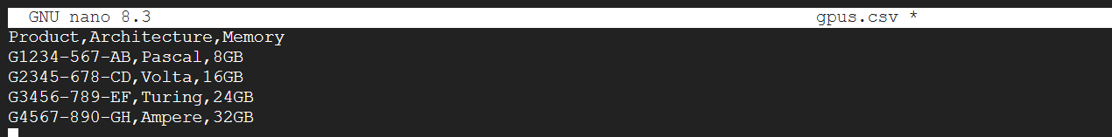

Gpus.csv

Intel-cpus.csv

Working of the RegEx.